NAME : Ibrahim Fouad

ID :18107773

API :POKIMON GO

Each Pokemon has three base stats, Name, Height and Weight which determine how innately it is in each of these areas. These effect how much HP and damage each move can do along with its level and the typing of the moves. Returns a JSON array where each element is a...

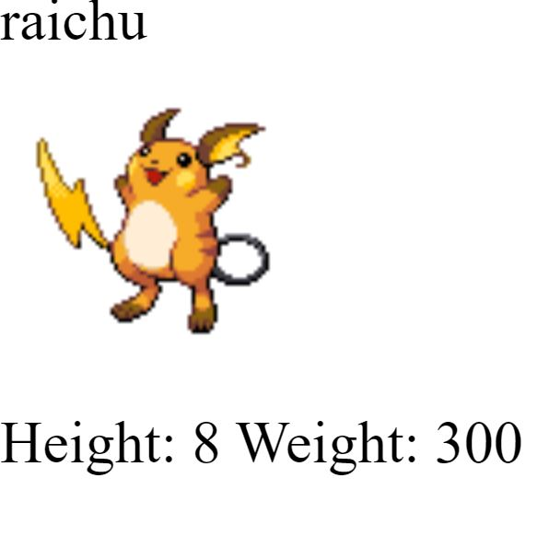

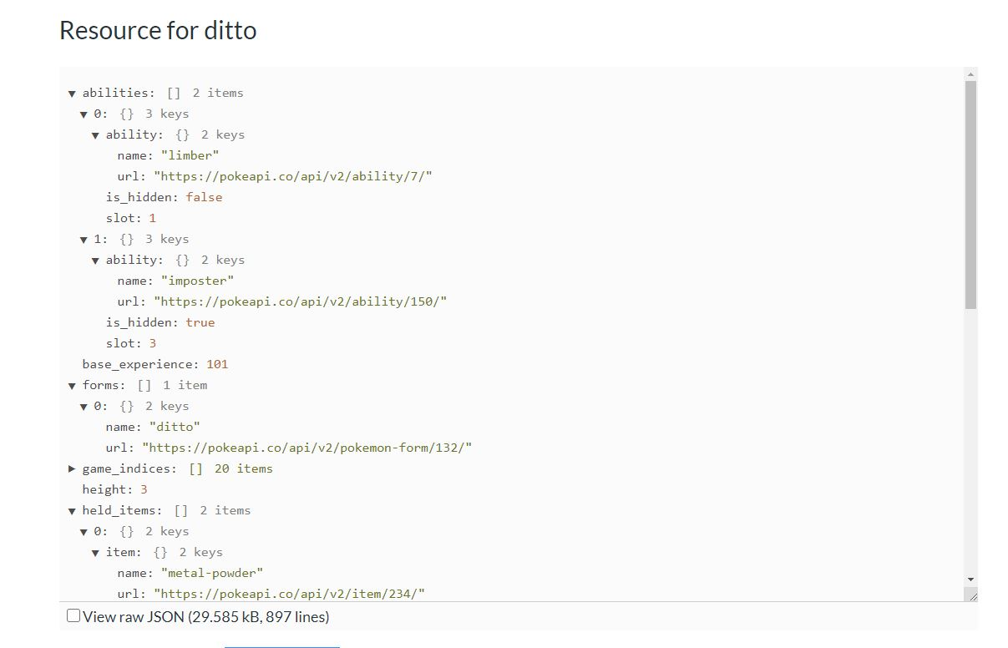

## What is this?

This is a full RESTful API linked to an extensive database detailing everything about the Pokémon main game series.